Kacey Morris

CST 235  November 8, 2020

ejb and cdi

This is my own work, as influenced by class time and demonstrations.

Bitbucket URL:

Theory of Operation:

For this assignment, CDI injections and the use of EJBs were introduced. For the first part of the assignment, the alternatives tag in the beans.xml file was manipulated to demonstrate the use of interfaces in Java webpages. The second part of the assignment did something similar, except the table of orders changed depending on the child class selected as the alternative. Finally, in the third part of the assignment, we learned about timers and how to trigger timed events with an action, like submitting a form, or simply using a timer to run actions independently.

Classes-

Order

Orders

OrderBusinessService

AnotherOrderBusinessService

MyTimerService

Methods-

formController.onSubmit(user)

service.test()

Timer.setTimer()

Variables-

Timer

BusinessService

Orders

Pages-

TestForm.xhtml

TestResponse.xhtml

Part 1:

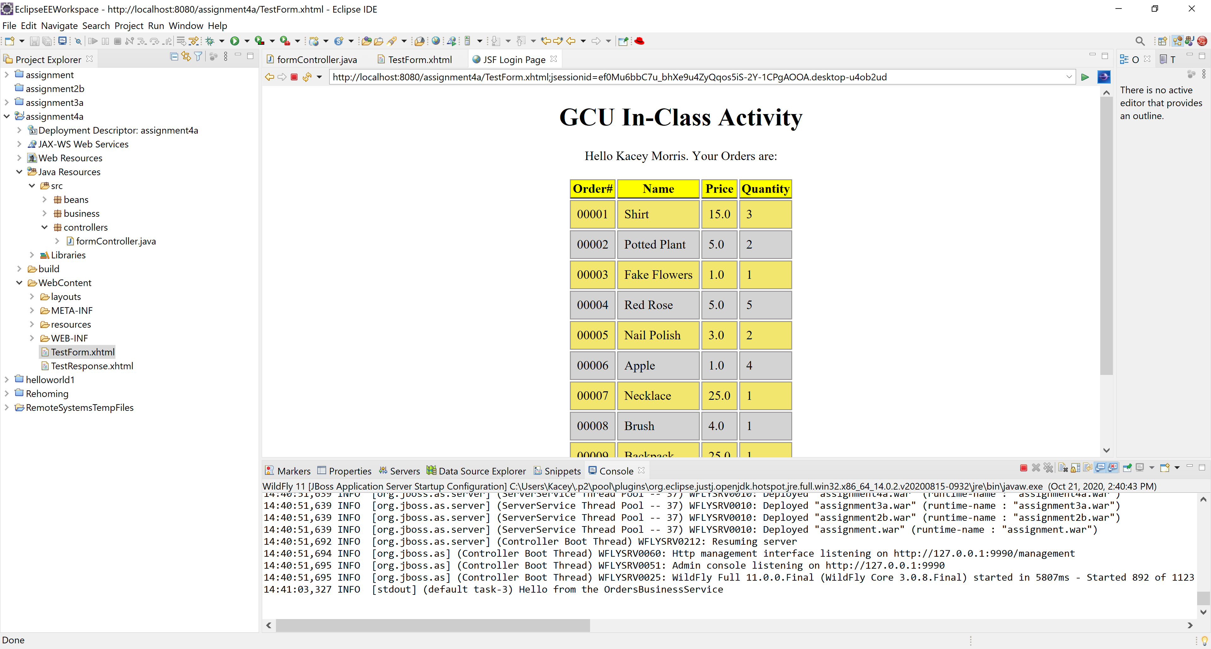

“Hello from the OrderBusinessService” printing in the console after valid data is submitted from the Test Form page.

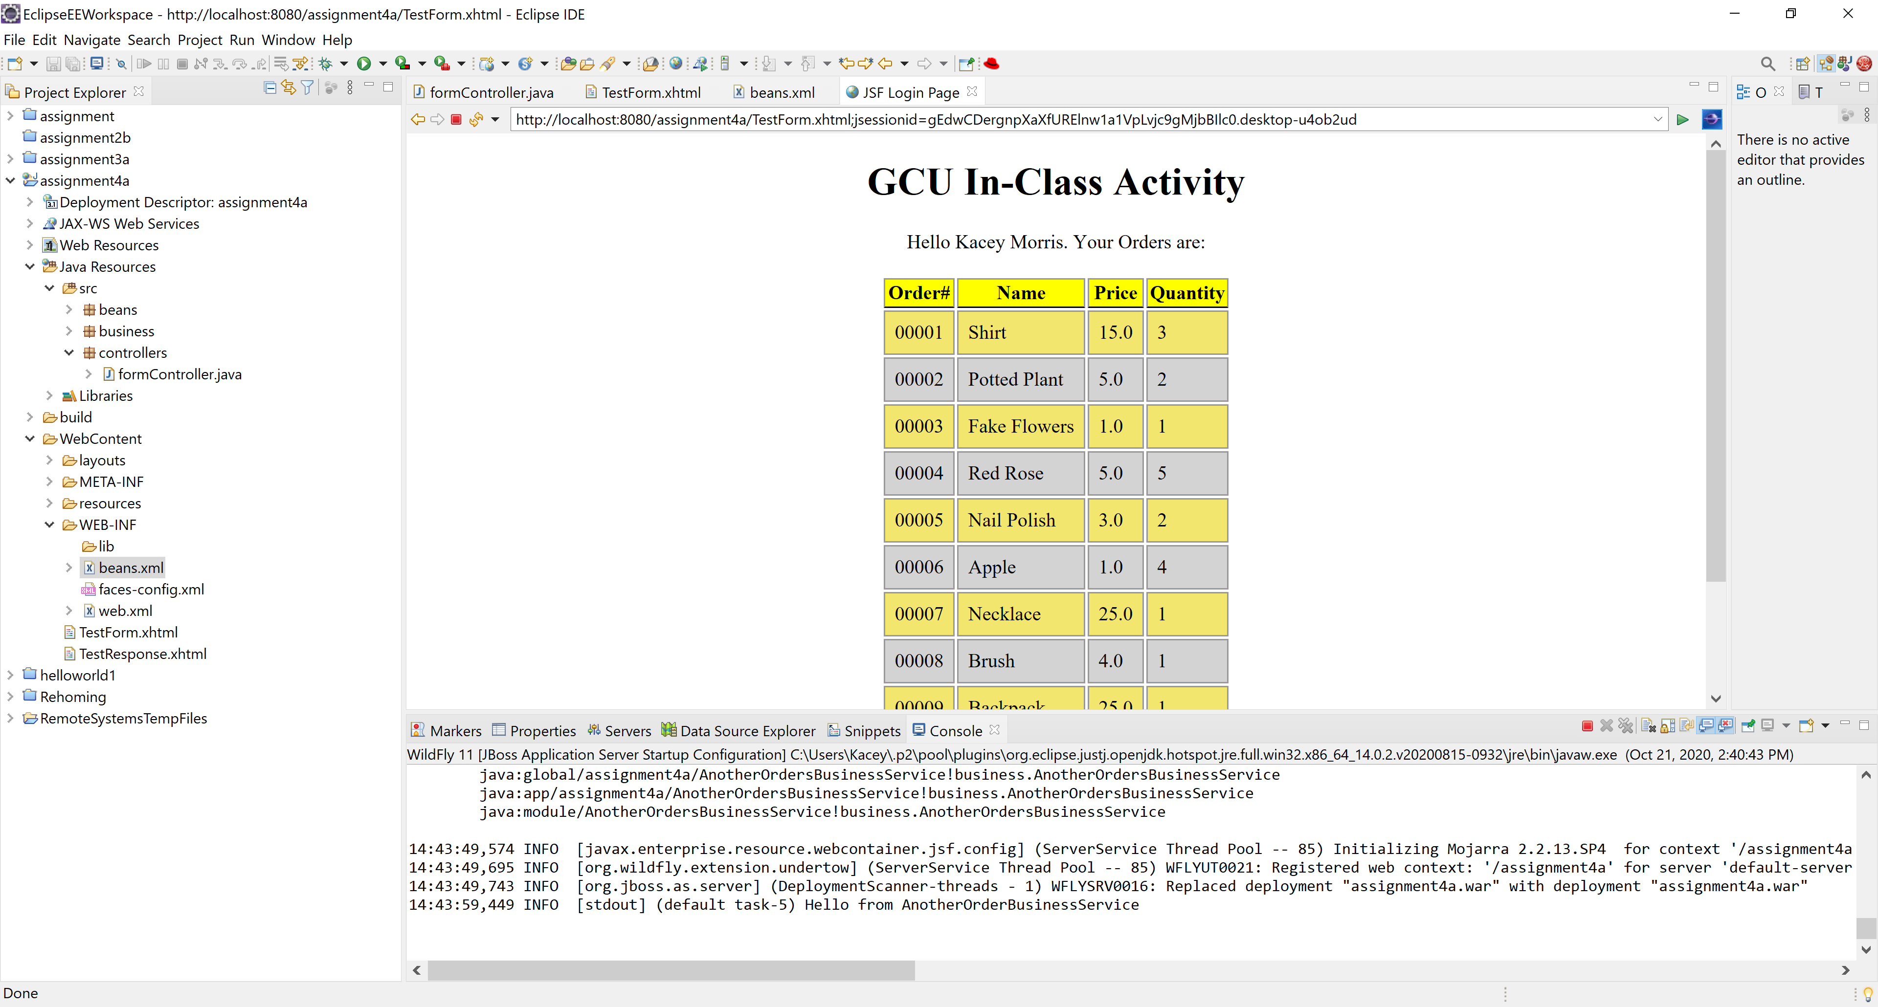

“Hello from AnotherBusinessService” printing in the console after valid data has been submitted to the TestForm page. The only change was in the beans.xml file, where the alternative is now business.AnotherOrderBusinessService instead of business.OrderBusinessService.

Part 2:

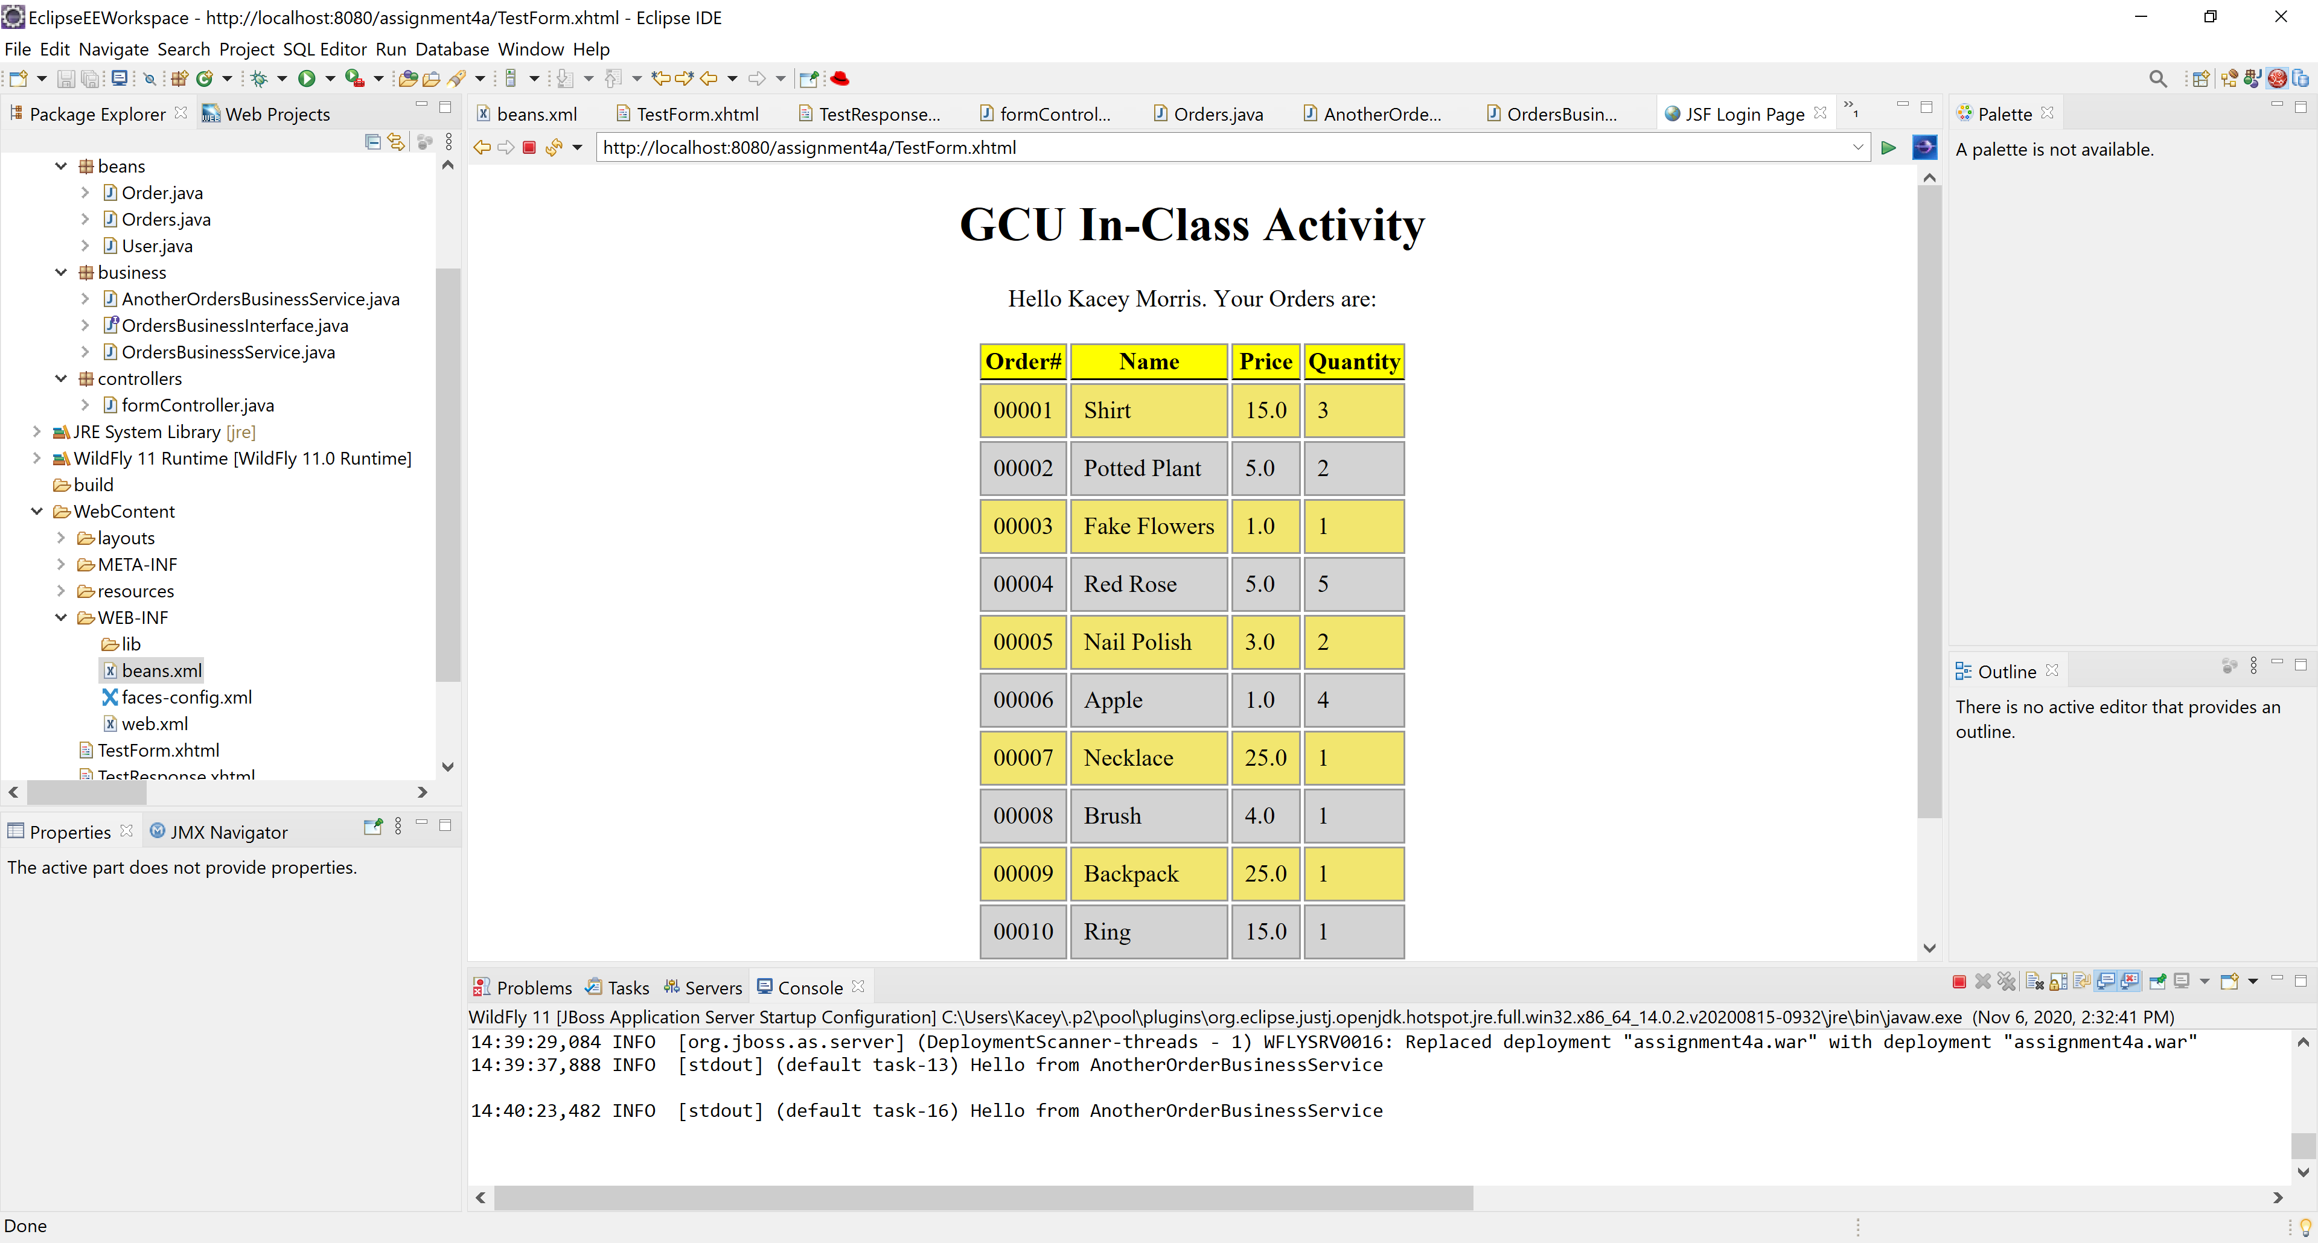

Orders displaying from AnotherOrderBusinessService after manipulating the response page to display the orders in the service.

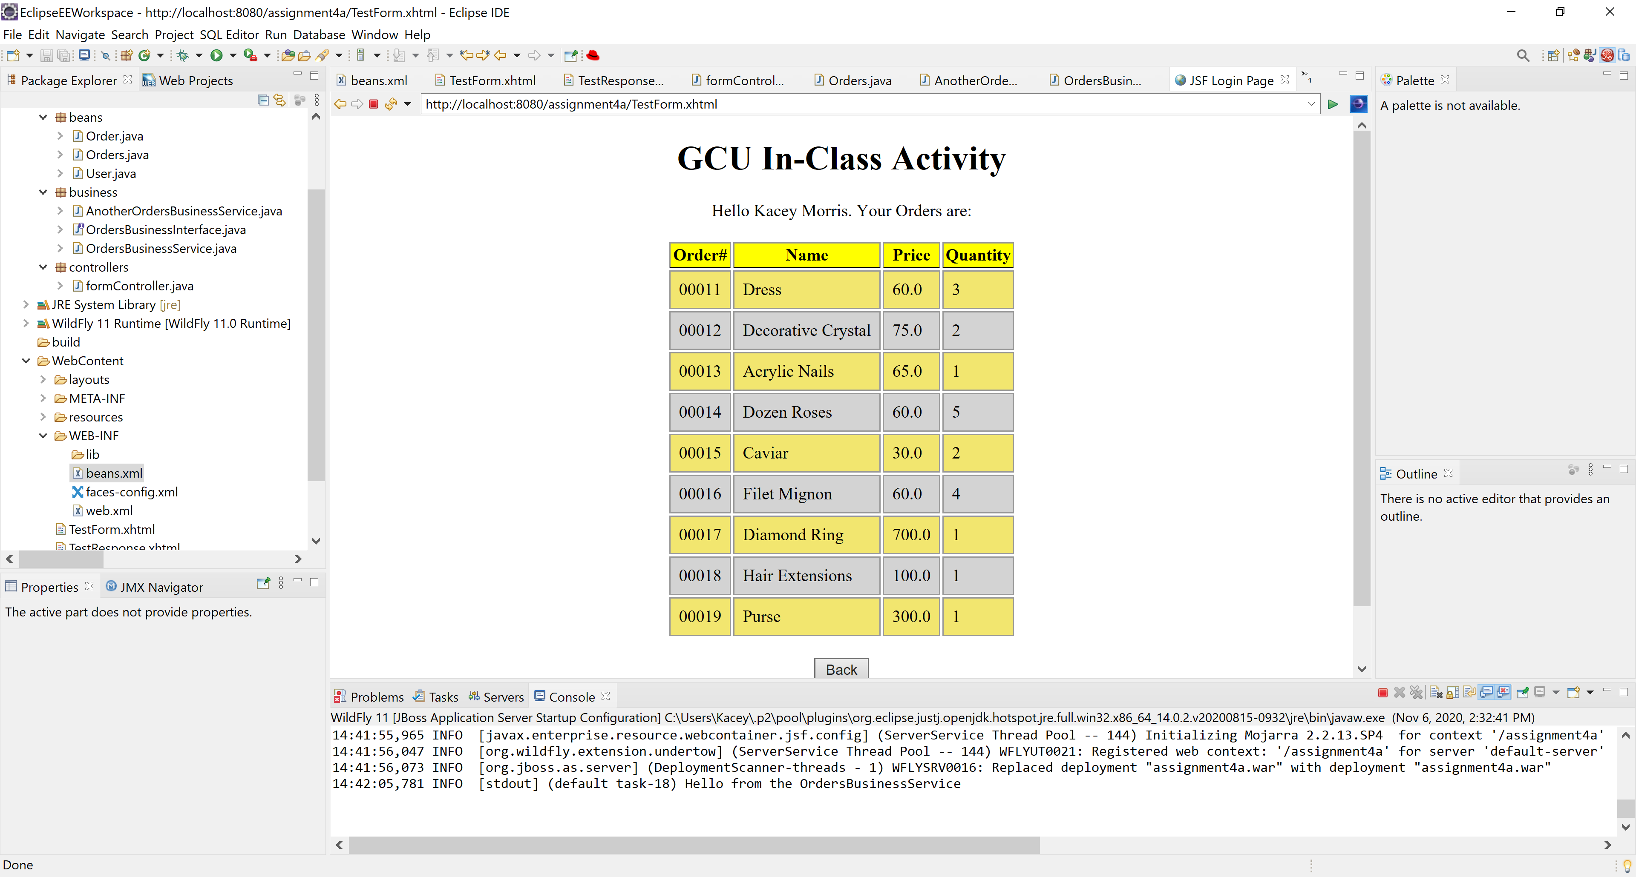

Orders displaying from OrderBusinessService after altering the beans.xml file to make this subclass the primary alternative.

Part 3:

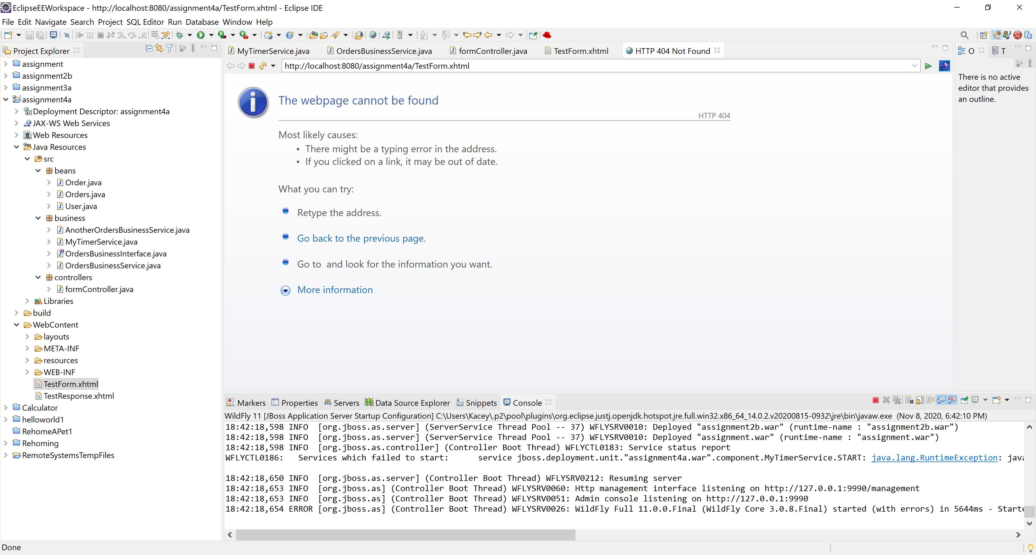

Expectation: Scheduled and Programmatic Timeout messages displayed in console.

Reality: I am not sure why this no longer works. I got this section of the activity working with timers Friday in class, but my Eclipse has been acting up and the first form no longer even starts. I believe this is because, after downloading dbeaver, my IDE has been displaying errors for all projects. I am not sure why, but I believe it is connected with dbeaver. I tried uninstalling dbeaver, which did not work. I tried uninstalling Eclipse, which did not work. It is simply unable to open. I will continue working on it but as of now, this is what I have.